|  |  |  |  |  |  |
| --- | --- | --- | --- | --- | --- |
| Date | 29-Nov-22 | | | Tester Name | Janette Paus |
| Environment | Penfax - Test 2 | | | Login used |  |
| Operating System | Windows | Version: 21H2 | Update Number: | | |
| Software Used | Select Software | Version: 107.0.1418.56 | Update Number: | | |
| Select Software | Version: | Update Number: | | |
| Application Release version | R22.4.1 | | | | |
| Test Case Title | E 19.02 | | | | |
| Test Type | Regression | | | | |
| Test Scenario | Process Terminal Illness Payment (partial) | | | | |
| Expected Results | That the payment will process, and member profile status will not change after the payment has processed. The remaining funds will be in the account, the taxes will be correct, according to the 10/20/30 rule. | | | | |
| Pass/Fail | Select | | | JIRA# |  |

Find an Active PEPP Member:

SID 299208:

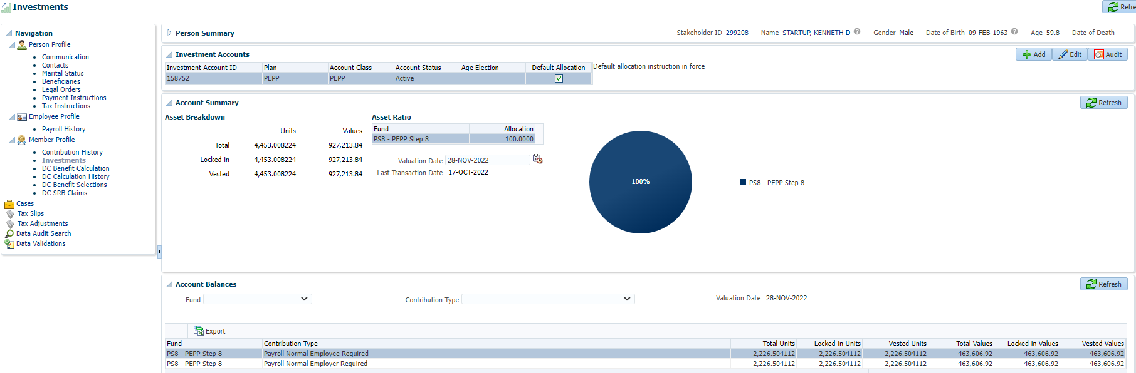

Confirm employment with ER:

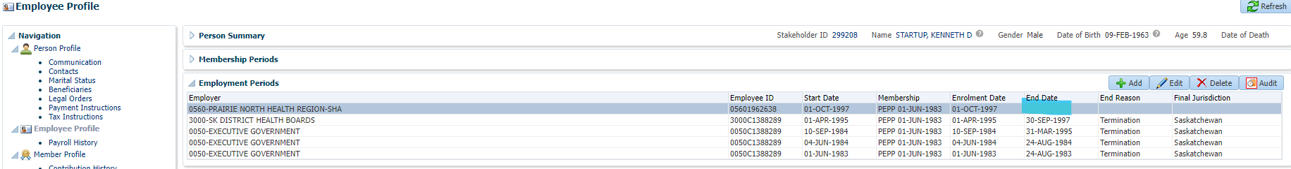

Add Terminal Illness payment and Payment Instruction for $30,000 gross and click Save:

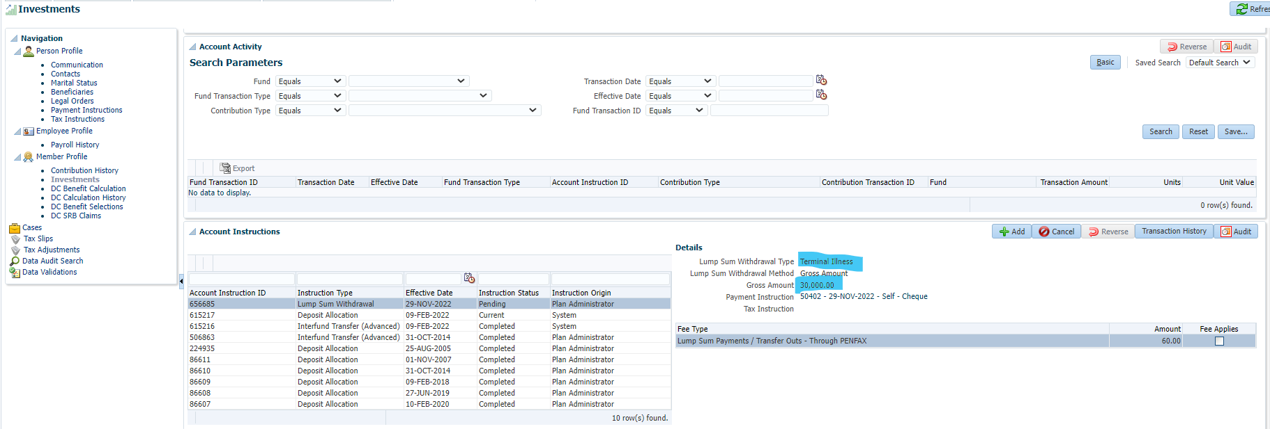

Allow PIT to run then check the payment and taxes that were processed.

Next day:

Same Scenario, different Member:

SID 263903 – Terminal Illness $30,000

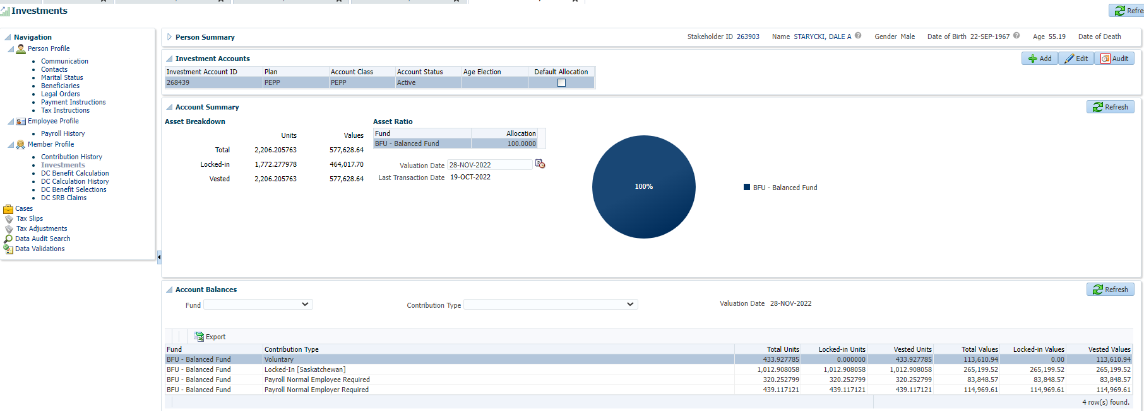

Confirm employment with ER:

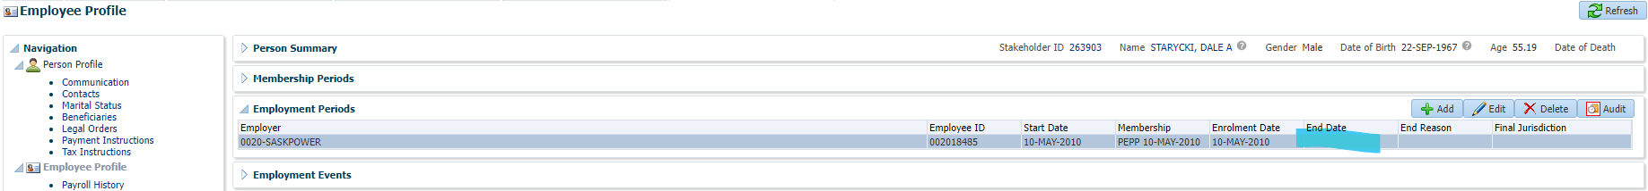

Add Terminal Illness payment and Payment Instruction for $25,000.00 gross and click Save:

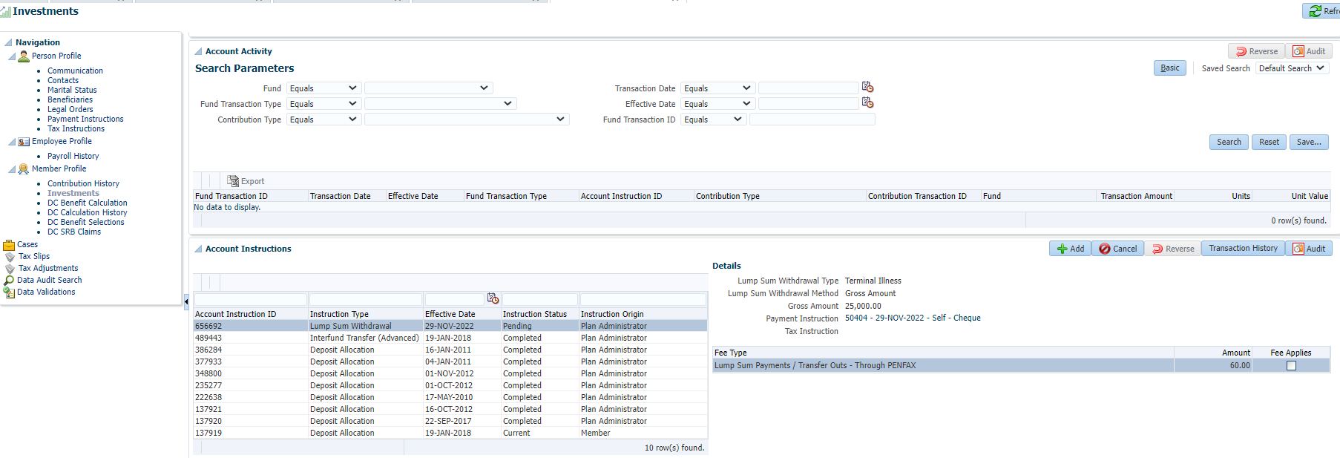

Allow PIT to run then check the payment and taxes that were processed.

Next day: